Algorithm for the simulation

To tackle this problem of validating the credit card numbers. We are going to approach the problem using the flowchart of how to approach problems:

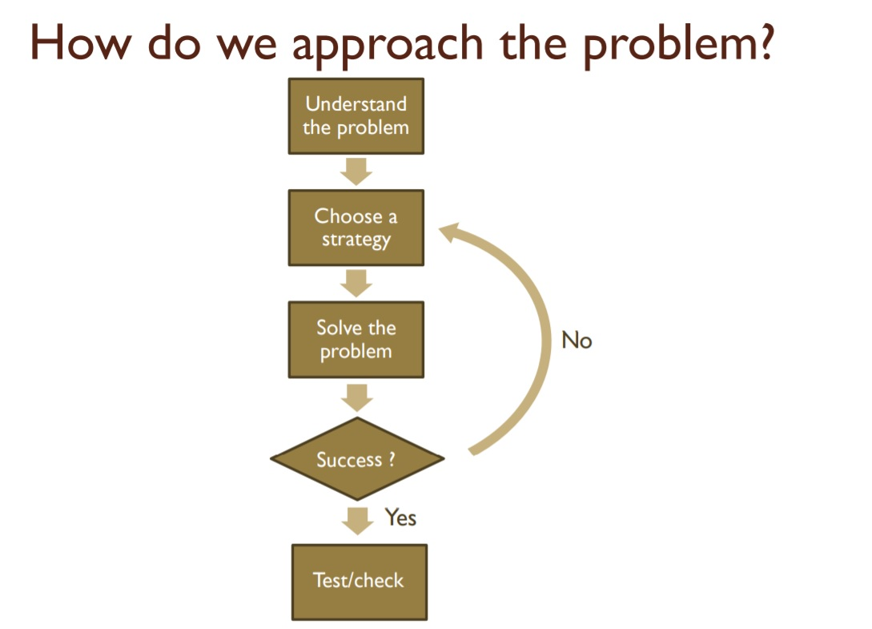

**Understanding the problem:**

The problem is that someone wants to simulate a program that can detect whether a provided credit card number is a valid number or not. Doing so by following the Mod 10 check, stated in the assignment.

**Choose a strategy:**

We choose to use the solution strategy “The divide the problem into several subproblems”. Using this will help us simplify the problem and dividing the bigger problem into little smaller problems. When dividing the bigger problem into sufficient amount of smaller problems, go over to solving those little problems one by one. When completing this, we can say that we have solved our bigger problem.

The bigger problem has to be divided into subproblems to get the simulation program.

**The main problem**: create a program that simulates the validation detection of credit card numbers.

**Subprobem1**: create an algorithm that allows the simulation to exist, following the Mod 10 check described in the assignment.

**Subproblem2**: Translate you algorithm into a flowchart.

**Subproblem3**: Implement your algorithm to Python.

**Solving the problem:**

Here, we are only going to present the solution of the first subproblem.

**The algorithm:**

1. Ask user for credit card number
2. Check whether the credit card number is between 13 and 16 digits
3. Check with what number the credit card number begins:
4. 4 for Visa cards
5. 5 for Master cards
6. 37 for American Express cards
7. 6 for Discover cards
8. Double every second digit from right to left. If doubling of a digit results in a two-digit number, add up the two digits to get a single-digit number.
9. Now add all single-digit numbers from Step 8.
10. Add all digits in the odd places from right to left in the card number.
11. Sum the results from Step 9 and Step 10.
12. If the result in Step 11 is divisible by 10, the card number is correct. Otherwise, the number is invalid.

**Success?**

We were able to solve the problem by analysing which steps there had to be taken.

**Test/check:**

When following this algorithm, the credit card number is being checked. Following the steps will lead to an answer whether the credit card number is valid or not. So, our general algorithm provides a solution when a user submit a credit card number. This solution is that either the number is valid or invalid.